A QUANTITATIVE ANALYSIS OF CANDIDATES IN THE 2019 LOK SABHA ELECTION

Team leader:R.Karthiga

Team members:A.Kabitha

K.Jayapiriya

J.Jayasudha

OVER VIEW

The lok sabha is composed of representation of people chosen by direct election on the basis of universal adult suffrage

PURPOSE

General election were heldin india in seven phase from 11April to 19 May 2019 to elect the members of the 17th Lok sabha.votes were counted and the result was declared on 23 May .the election resulted in a landslide victory for the BJP which won 303 seats and formed the government

PROBLEM DEFINITION &DESIGN THINKING

Emathy map

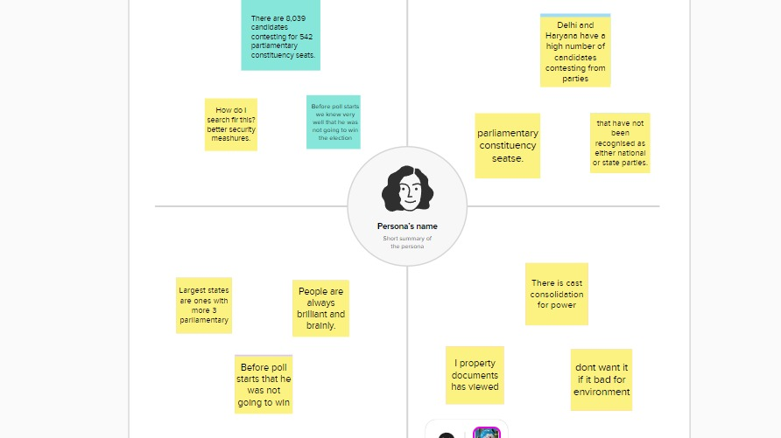

Ideation&Brainstorming Map

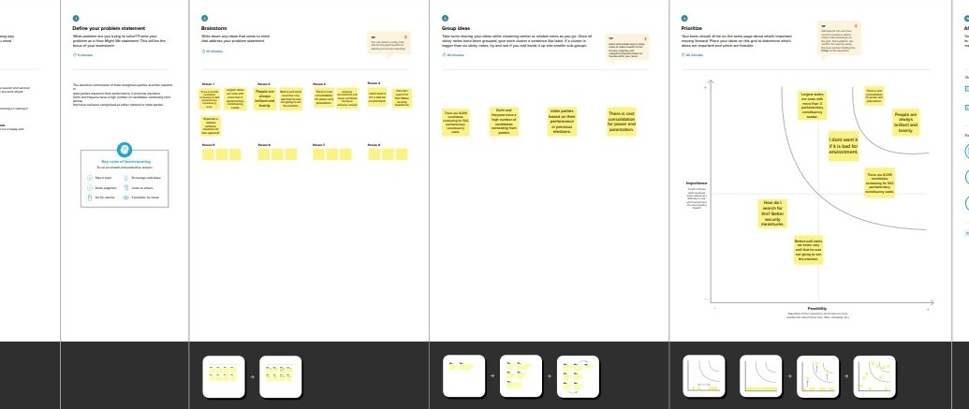

Result

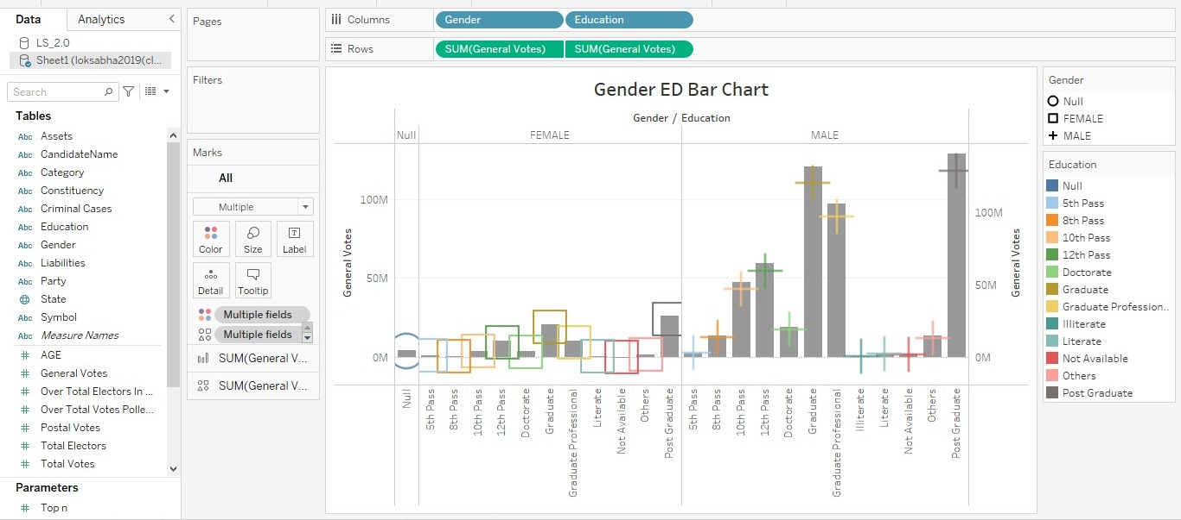

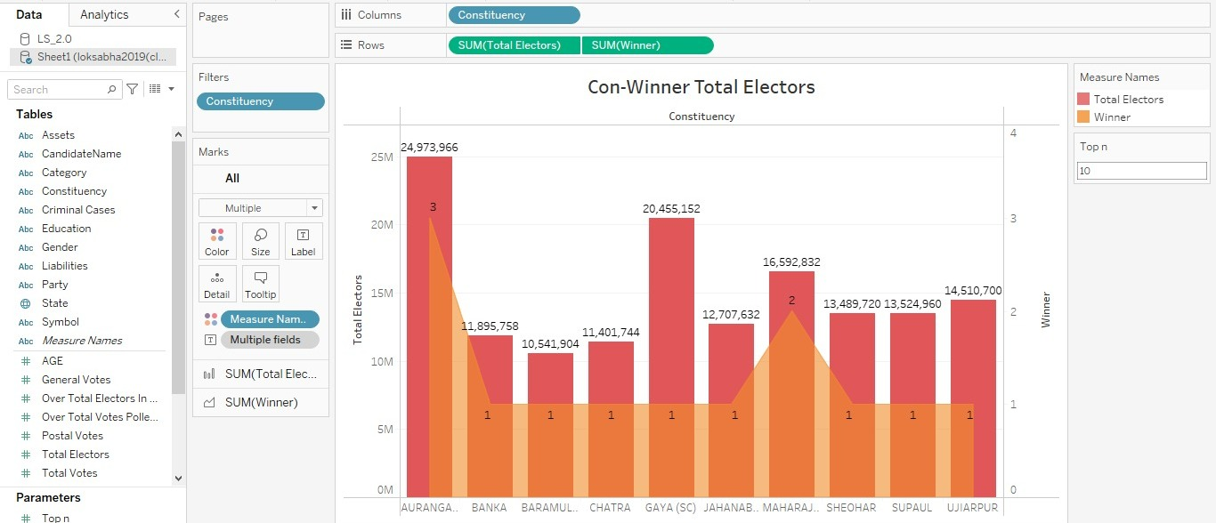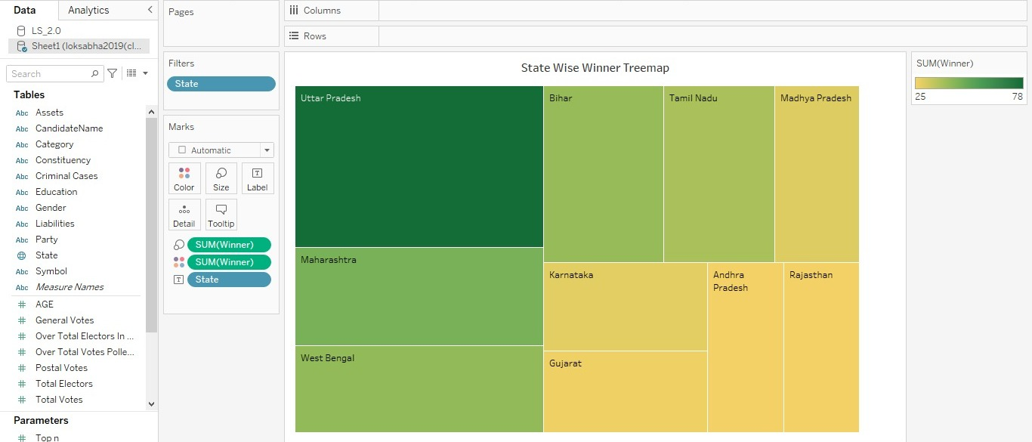

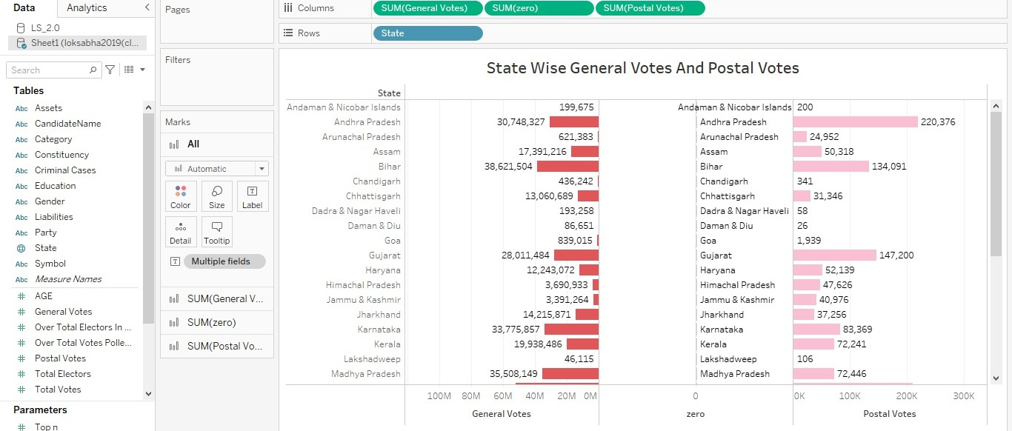

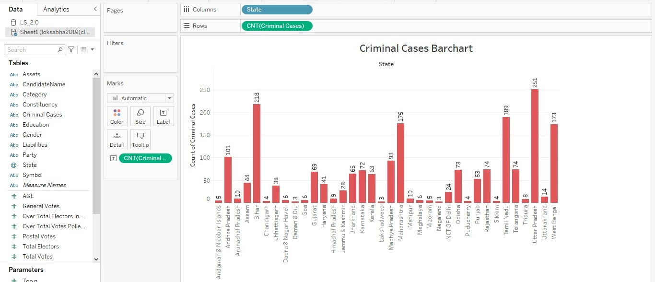

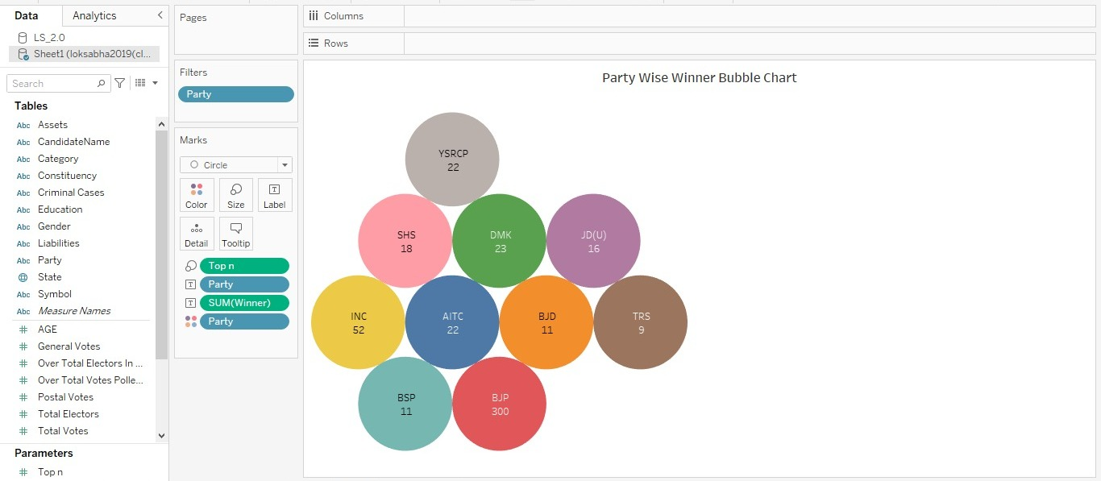

Advantage

1.one of the primary advantages of cost-saving

2.conducting election on a nation scale including parliamentary and state assembly election,requires substantial financial resources

Disadvantage

1.India would require singnificant constitutional amendments

2.The current constitution provisions mandate a fixed tenure for the lok sabha and state ligeslative assemblies and any alteration to this arrangement would require complex legal changes that could face resistance and hurdles

Conclusion

The Lok Sabha constitutionaly the house of the people is the lower house of india’s bicameral parliament , with the upper house being the Rajya Sabha. The houses meets in the LOk Sabha chambers of the parliment house, New Delhi.

s